Deploy Jenkins on ubuntu machine

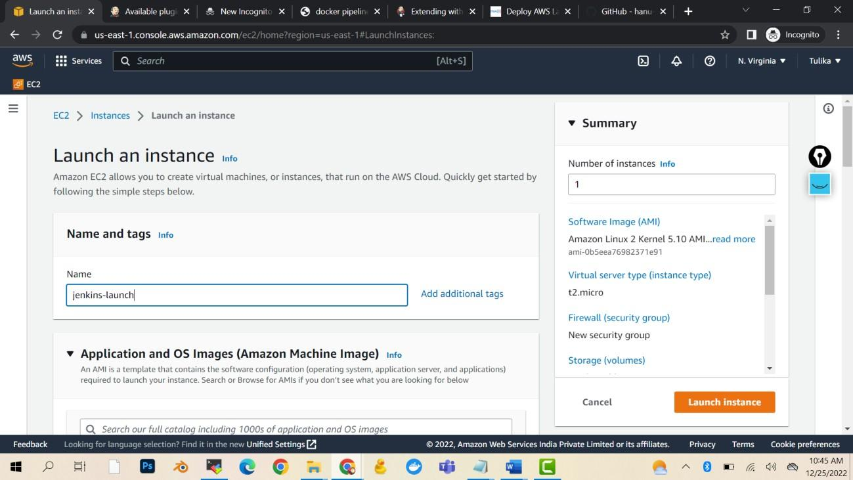

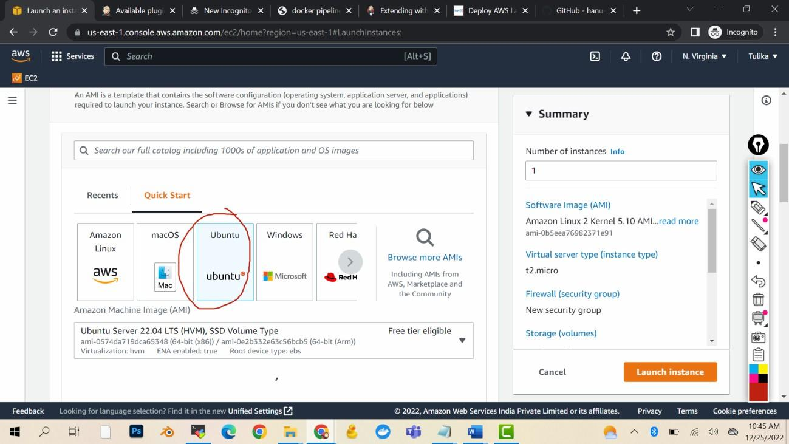

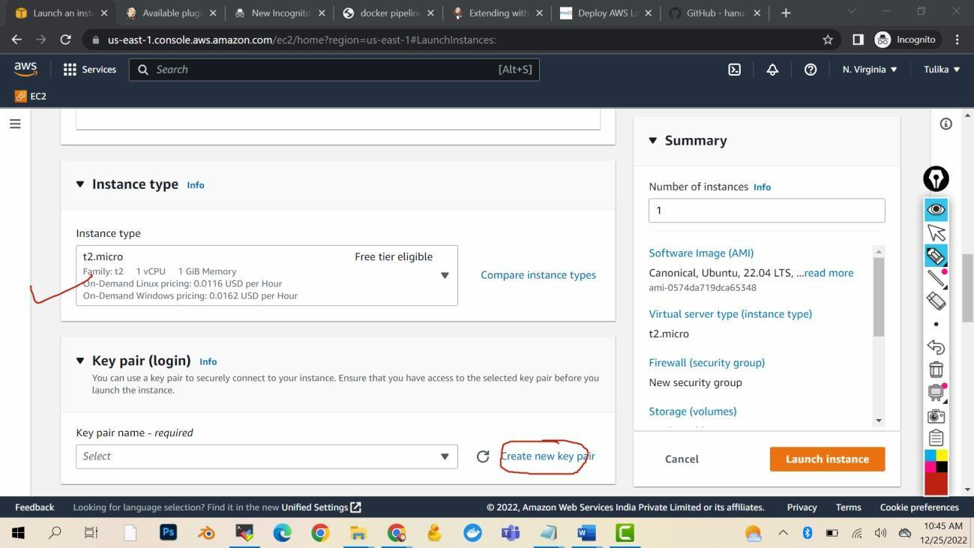

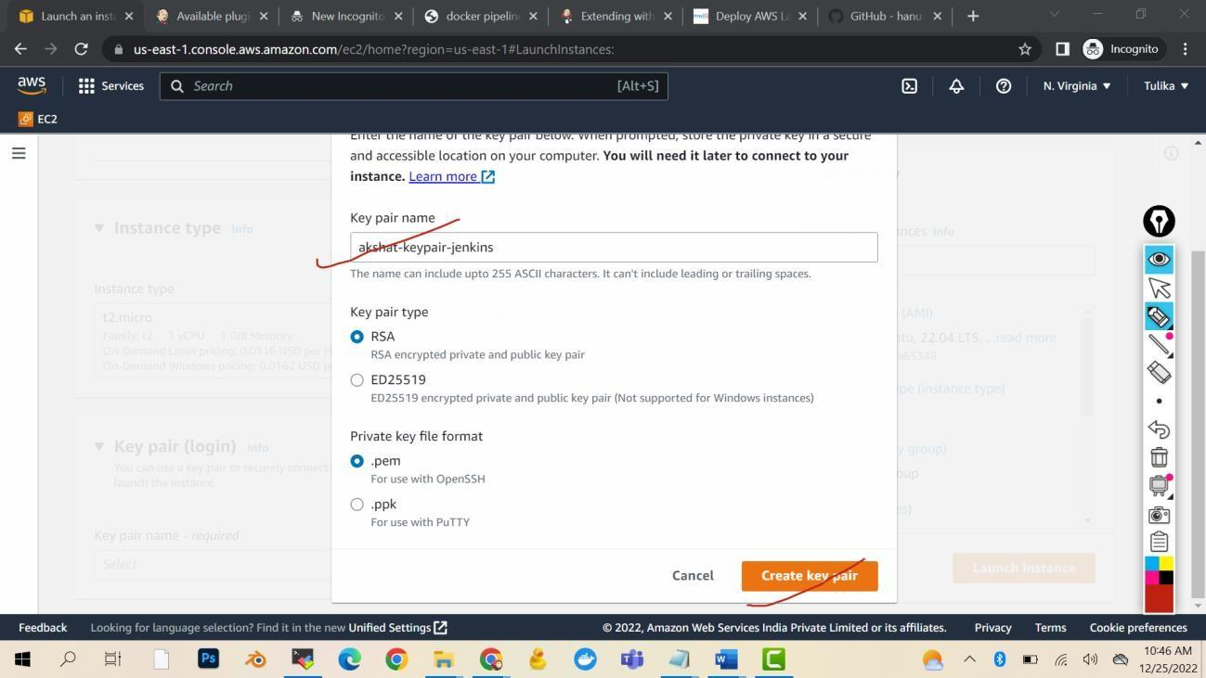

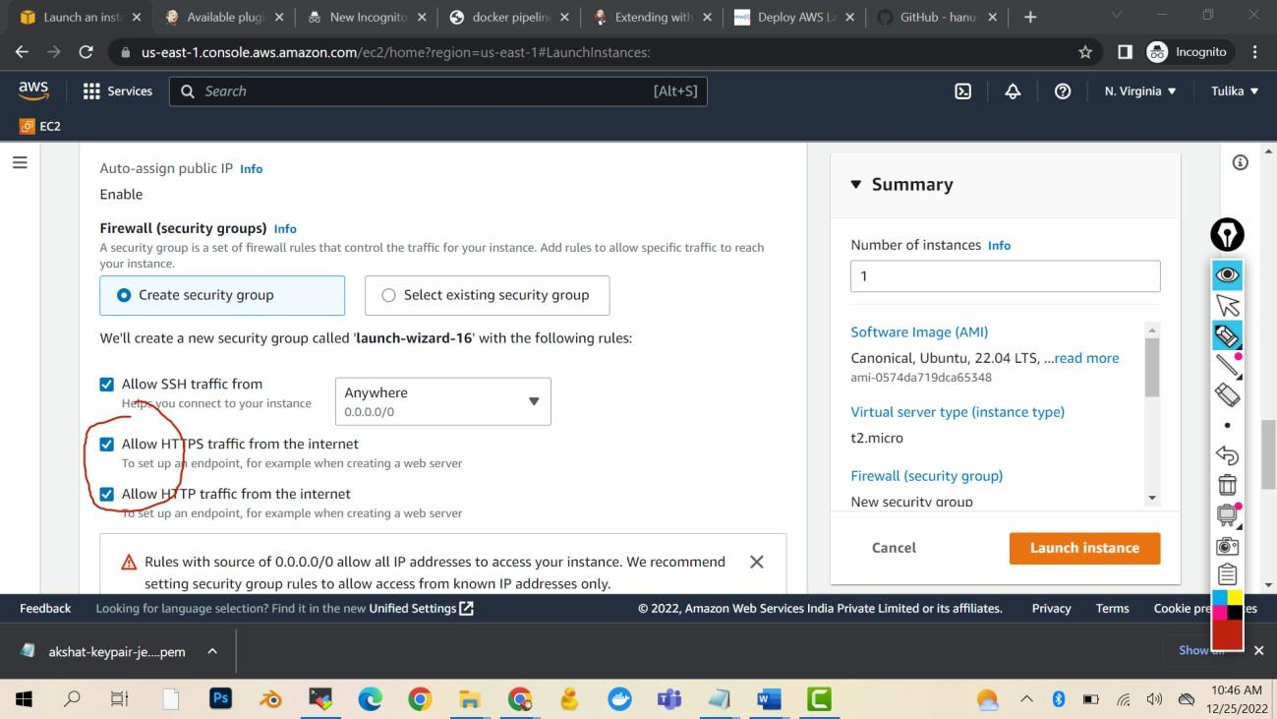

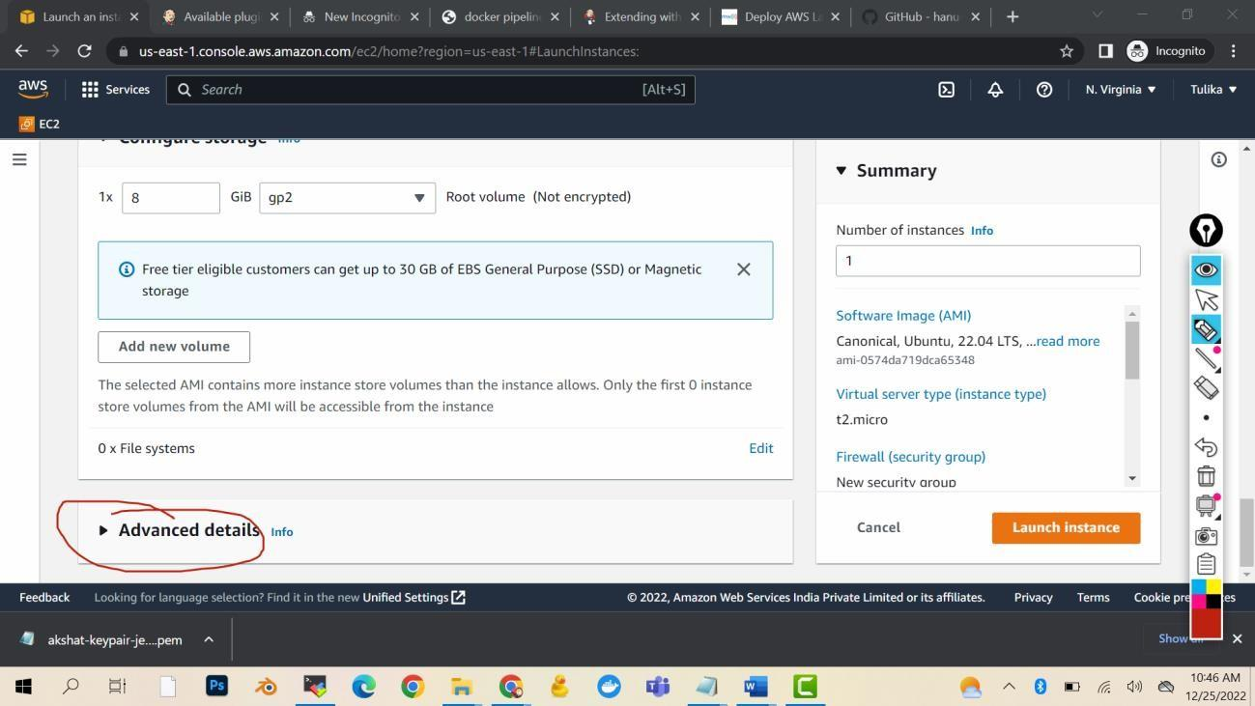

Launch instance

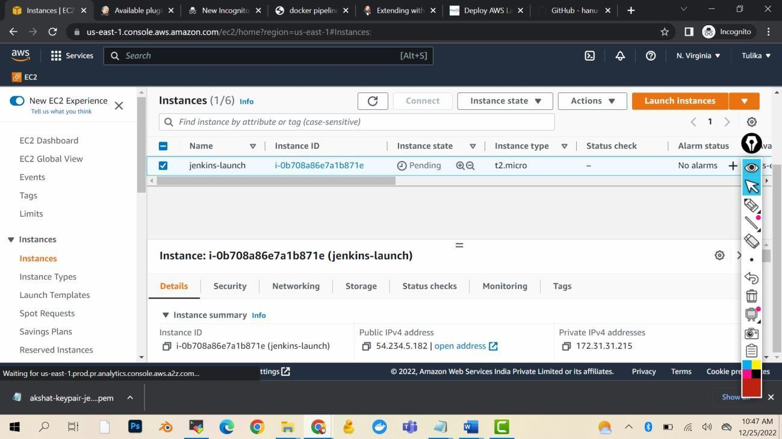

Wait for the Jenkins to launch

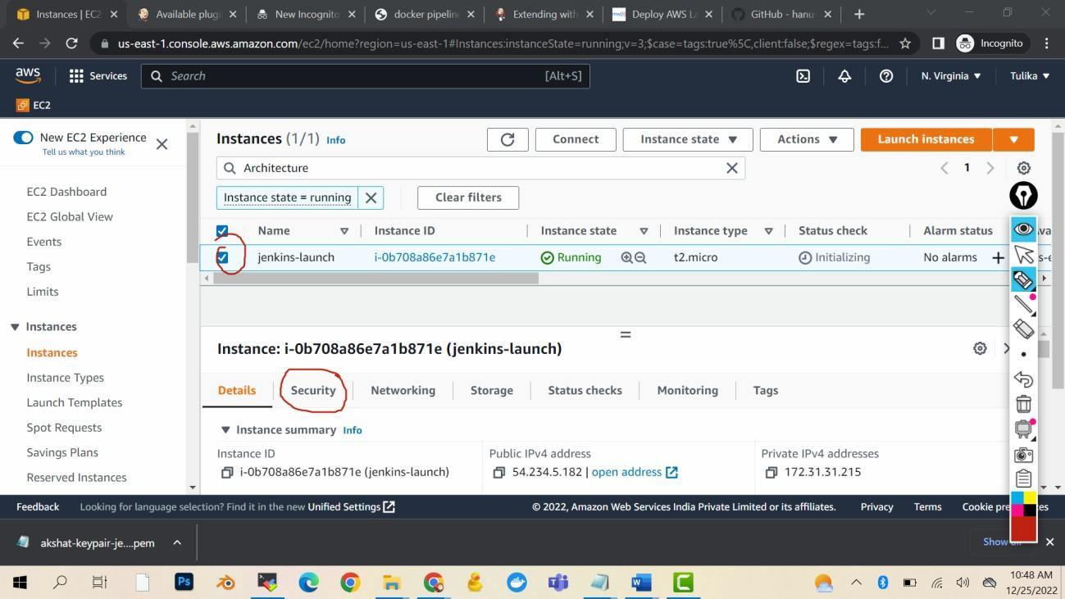

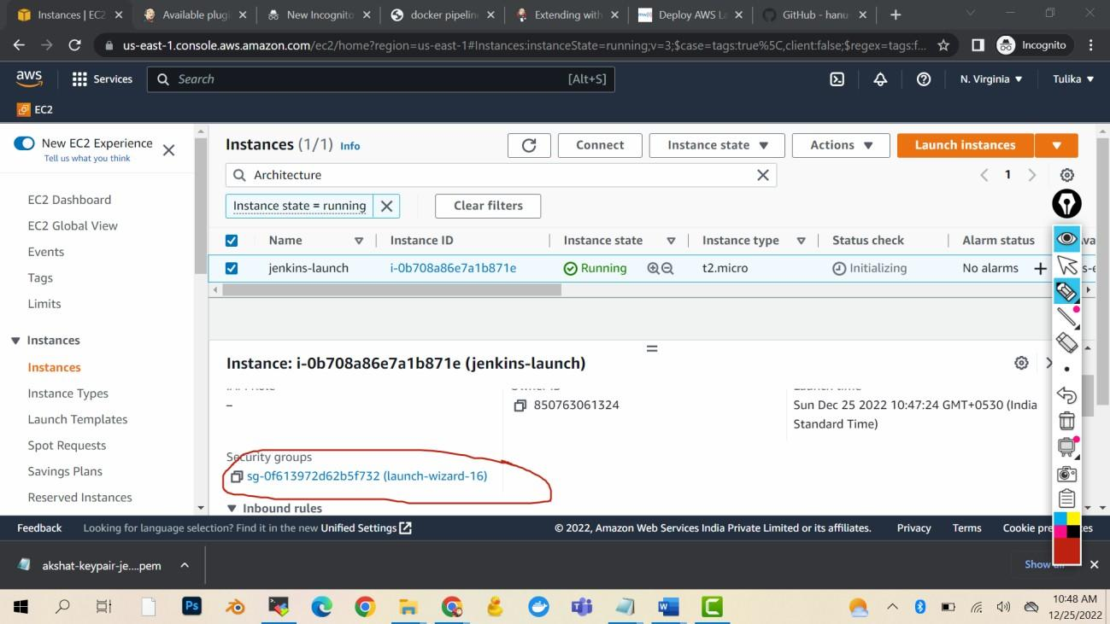

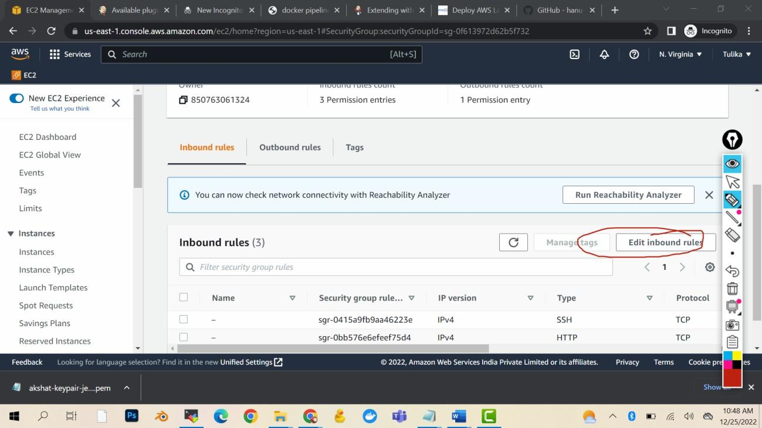

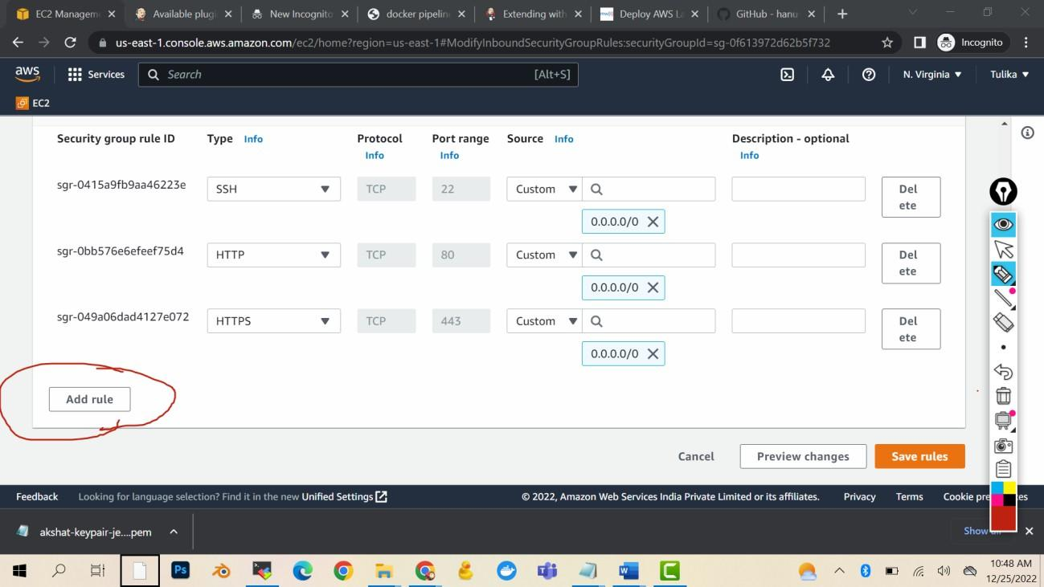

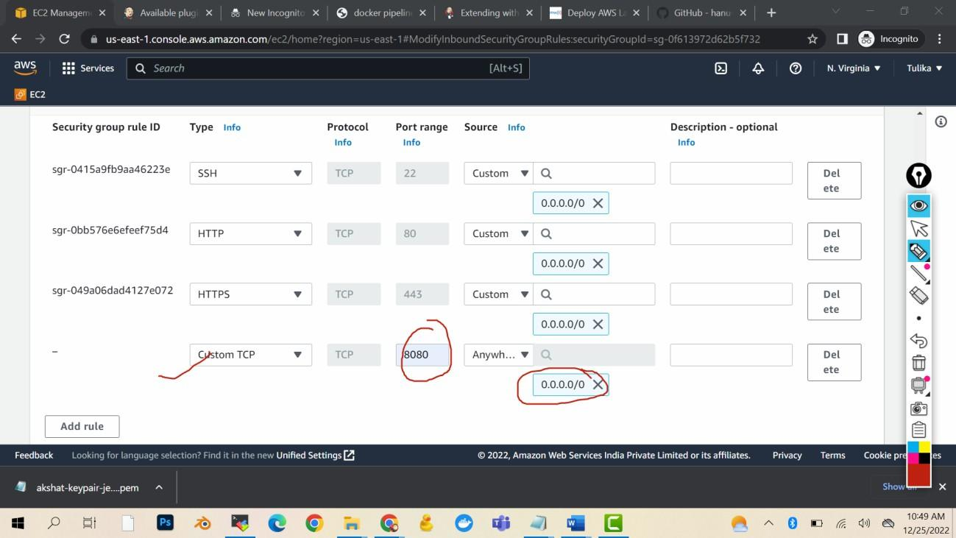

Save

Login in the machine

sudo su

# Command for installing Java 11 sudo apt-get update

sudo apt install default-jdk -y

# Command for installing maven sudo apt install maven -y

# Script for Jenkins installation

#Add Repository key to the system

curl -fsSL https://pkg.jenkins.io/debian-stable/jenkins.io-2023.key | sudo tee \

/usr/share/keyrings/jenkins-keyring.asc **>** /dev/null

echo deb **[**signed-by**=**/usr/share/keyrings/jenkins-keyring.asc] \

https://pkg.jenkins.io/debian-stable binary/ | sudo tee \

/etc/apt/sources.list.d/jenkins.list **>** /dev/null

# Install Jenkins

sudo apt-get update

sudo apt-get install jenkins -y

service jenkins start

Now copy public ip and paste it in the browser

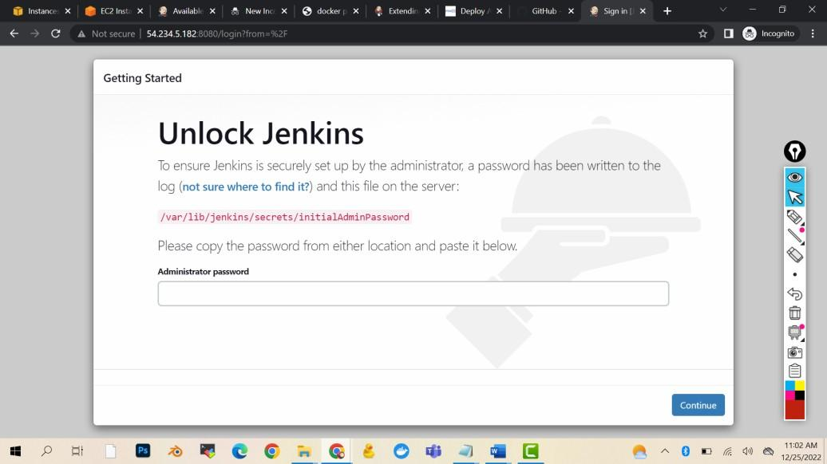

cat /var/lib/jenkins/secrets/initialAdminPassword

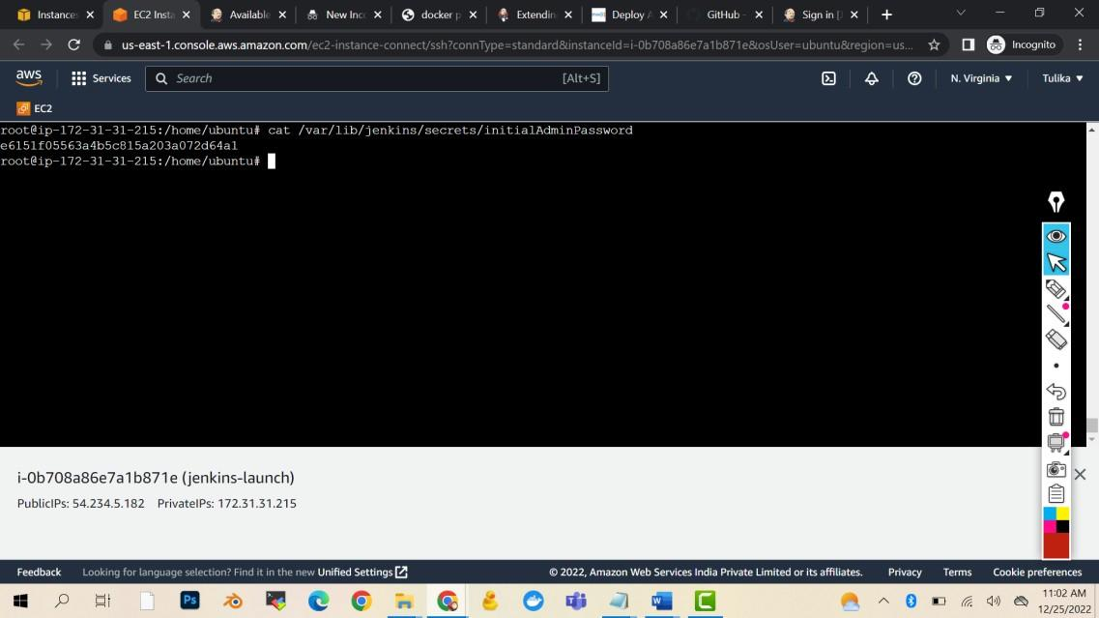

Copy the pass and paste in the browser

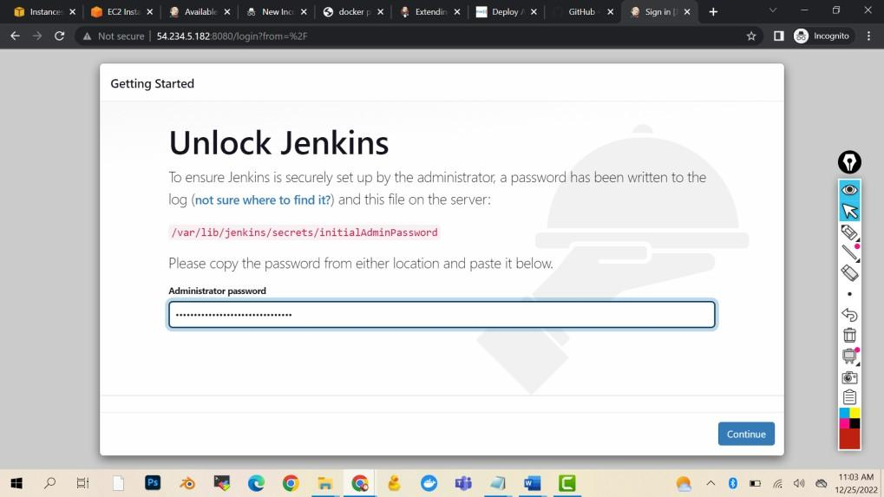

Continue

Install suggested plugins Username: admin

Pass: admin

Full name: Akshat

Email: [akshu20791@gmail.com](mailto:akshu20791@gmail.com)

Save and finish

Start using Jenkins